Chain Load Testing
Day 13: Performance-Based Assessment
Objective:
Mining metals and minerals from Earth requires the ability to lift extremely heavy loads. Equipment used for mining is tested to ensure that the correct equipment is used for the job, and that the equipment can safely lift a load without failing.
- In this activity you will analyze and graph data related to testing several types of chain slings used by cranes. From these data you will draw conclusions and make predictions about how these chains will function.
- Know the Score!
- As you work through this activity, keep in mind that you will be earning a grade for the following:
- how well you graph the data (50%)
- how well you interpret the data shown (50%)
- Procedure
- 1. Study the table below. The table shows the load limit for 5 sizes of chains used in three
different types of slings.
 | Maximum Load (lbs)
Chain size (mm) | Single chain sling  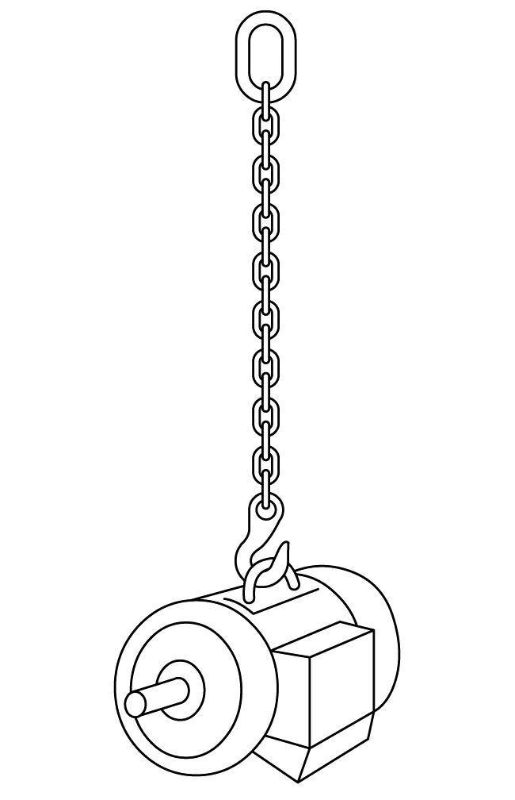 | Double chain sling  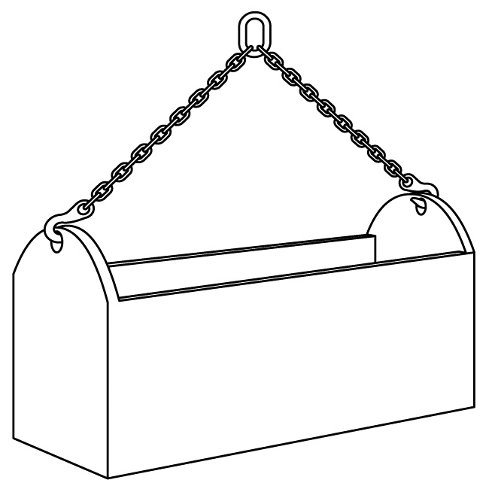 | Quadruple chain sling  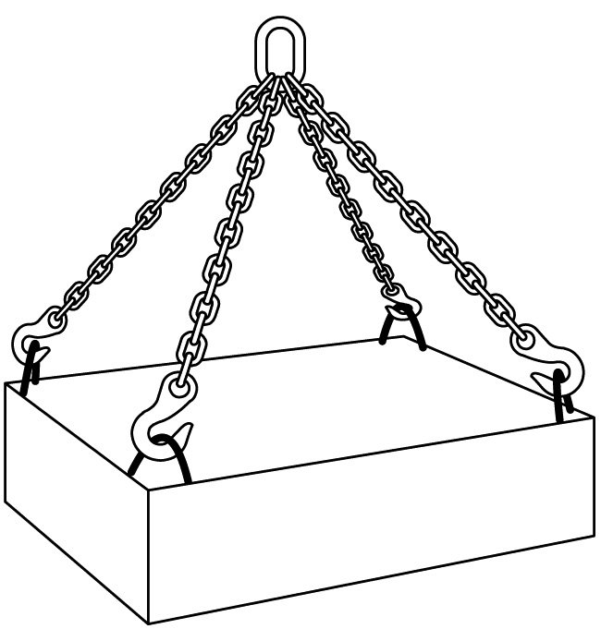
10 | 7,100 | 10,000 | 15,100
16 | 18,100 | 25,600 | 38,400
20 | 28,300 | 40,000 | 60,000
26 | 47,700 | 67,400 | 101,200
32 | 72,300 | 102,200 | 153,400

- 2. How many more pounds can a 16 mm quadruple chain sling hold than a 20 mm single chain sling?

- 3. Approximately how many times stronger is a 32 mm chain than a 10 mm chain?

- 4. In the space below, make a bar graph to display this data. Use a different shading pattern for the bars belonging to each type of chain sling. You may also use colored pencils if they are available. Draw a key for your bar graph beside the graph.
- Maximum Load Testing for Single, Double, and Quadruple Chain Slings
Maximum Load (lbs) | 150,000
Maximum Load (lbs) | 140,000
Maximum Load (lbs) | 130,000
Maximum Load (lbs) | 120,000
Maximum Load (lbs) | 110,000
Maximum Load (lbs) | 100,000
Maximum Load (lbs) | 90,000
Maximum Load (lbs) | 80,000
Maximum Load (lbs) | 70,000
Maximum Load (lbs) | 60,000
Maximum Load (lbs) | 50,000
Maximum Load (lbs) | 40,000
Maximum Load (lbs) | 30,000
Maximum Load (lbs) | 20,000
Maximum Load (lbs) | 10,000
Maximum Load (lbs) |  | 10 | 16 | 20 | 26 | 32
Maximum Load (lbs) |  | Chain Size (mm)
- Analysis
- 5. The cost of the chain increases with size. If you need to lift a box that weighs 25,000 lbs, what is the thinnest chain you could use, and what sling type would you need?

- 6. To lift a 60,000 lb boulder, what is the minimum size chain you can use for each sling type?

